TCF Bank Football Stadium Tour
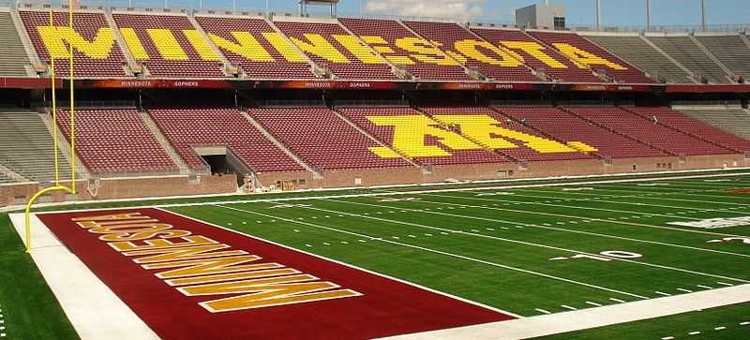
Wednesday, August 14, 6:00 PM CT
Completed in 2009, the University of Minnesota’s TCF Bank Football Stadium is the University’s fourth stadium used for football and can seat up to 50,805 fans. After NVMTS 13 comes to a close on Wednesday evening, you are invited to take a tour of this impressive structure at 6:00 PM CT. The tour will last between 60 and 90 minutes, and is free for all NVMTS guests.

If you would like to participate in this event, please sign up with the conference coordinators no later than Tuesday, August 13.

