SIGNAL and IMAGE DENOISING
USING VC-LEARNING THEORY

Vladimir Cherkassky
Dept. Electrical & Computer Eng.
University of Minnesota
Minneapolis MN 55455 USA

Email cherkass@ece.umn.edu

Tutorial at ICANN-2002
Madrid, Spain, August 27, 2002

OUTLINE

BACKGROUND

Predictive Learning

VC Learning Theory

VC-based model selection

- SIGNAL DENOISING as FUNCTION ESTIMATION
Principal Issues for Signal Denoising
VC framework for Signal Denoising
Empirical comparisons: synthetic signals
ECG denoising

- IMPROVED VC-BASED SIGNAL DENOISING
Estimating VC-dimension implicitly
FMRI Signal Denoising
2D Image Denoising

4. SUMMARY and DISCUSSION
1. PREDICTIVE LEARNING and VC THEORY

• The problem of predictive learning:
GIVEN past data + reasonable assumptions
ESTIMATE unknown dependency for future predictions
• Driven by applications (NOT theory):
medicine
biology: genomics
financial engineering (i.e., program trading, hedging)
signal/ image processing
data mining (for marketing)
........
• Math disciplines:
function approximation
pattern recognition
statistics
optimization …….

MANY ASPECTS of PREDICTIVE LEARNING

• MATHEMATICAL / STATISTICAL
foundations of probability/statistics and function approximation

• PHILOSOPHICAL

• BIOLOGICAL

• COMPUTATIONAL

• PRACTICAL APPLICATIONS

• Many competing methodologies
BUT lack of consensus (even on basic issues)

STANDARD FORMULATION for PREDICTIVE LEARNING

• LEARNING as function estimation = choosing the ‘best’ function from a given set of functions [Vapnik, 1998]

• Formal specs:
Generator of random X-samples from unknown probability distribution
System (or teacher) that provides output y for every X-value according to (unknown) conditional distribution P(y/X)
Learning machine that implements a set of approximating functions f(X, w) chosen a priori where w is a set of parameters

• The problem of learning/estimation:
Given finite number of samples (Xi, yi), choose from a given set of functions f(X, w) the one that approximates best the true output
Loss function L(y, f(X,w)) a measure of discrepancy (error)
Expected Loss (Risk) R(w) = $\int{\text{ L}(\text{y, f}(X,w))\text{ dP}(X\text{,y})}$
The goal is to find the function f(X, wo) that minimizes R(w) when the distribution P(X,y) is unknown.
Important special cases
(a) Classification (Pattern Recognition)
output y is categorical (class label)
approximating functions f(X,w) are indicator functions
For two-class problems common loss
L(y, f(X,w)) = 0 if y = f(X,w)
L(y, f(X,w)) = 1 if y f(X,w)
(b) Function estimation (regression)
output y and f(X,w) are real-valued functions
Commonly used squared loss measure:
L(y, f(X,w)) = [y - f(X,w)]2

→ relevant for signal processing applications (denoising)
WHY VC-THEORY?

• USEFUL THEORY (!?)
- developed in 1970’s
- constructive methodology (SVM) in mid 90’s
- wide acceptance of SVM in late 90’s
- wide misunderstanding of VC-theory

• TRADITIONAL APPROACH to LEARNING
GIVEN past data + reasonable assumptions
ESTIMATE unknown dependency for future predictions

- Develop practical methodology (CART, MLP etc.)
- Justify it using theoretical framework (Bayesian, ML, etc.)
- Report results; suggest heuristic improvements
- Publish paper (optional)

VC LEARNING THEORY

• Statistical theory for finite-sample estimation

• Focus on predictive non-parametric formulation

• Empirical Risk Minimization approach

• Methodology for model complexity control (SRM)

• VC-theory unknown/misunderstood in statistics

References on VC-theory:
V. Vapnik, The Nature of Statistical Learning Theory, Springer 1995
V. Vapnik, Statistical Learning Theory, Wiley, 1998
V. Cherkassky and F. Mulier, Learning From Data: Concepts, Theory and Methods, Wiley, 1998

CONCEPTUAL CONTRIBUTIONS of VC-THEORY
• Clear separation between
problem statement
solution approach (i.e. inductive principle)
constructive implementation (i.e. learning algorithm)

- all 3 are usually mixed up in application studies.

• Main principle for solving finite-sample problems
Do not solve a given problem by indirectly solving a more general (harder) problem as an intermediate step
- usually not followed in statistics, neural networks and applications.
Example: maximum likelihood methods

• Worst-case analysis for learning problems
Theoretical analysis of learning should be based on the worst-case scenario (rather than average-case).

STATISTICAL vs VC-THEORY APPROACH

GENERIC ISSUES in Predictive Learning:
• Problem Formulation
Statistics: density estimation
VC-theory: application-dependent
Signal Denoising ~ real-valued function estimation

• Possible/ admissible models
Statistics: linear expansion of basis functions
VC-theory: structure
Signal Denoising ~ orthogonal bases

• Model selection (complexity control)
Statistics: resampling, analytical (AIC, BIC etc)
VC-theory: resampling, analytical (VC-bounds)
Signal Denoising ~ thresholding using statistical models
Structural Risk Minimization (SRM) [Vapnik, 1982]
• SRM Methodology (for model selection)
GIVEN training data and a set of possible models (aka approximating functions)

introduce nested structure on approximating functions

Note: elements Sk are ordered according to increasing complexity

So$⊂$ S1 $⊂$ S2 $⊂$...

Examples (of structures):
- basis function expansion (i.e., algebraic polynomials)
- penalized structure (penalized polynomial)
- feature selection (sparse polynomials)
- minimize Remp on each element Sk (k=1,2...) producing increasingly complex solutions (models).
- Select optimal model (using VC-bounds on prediction risk), where optimal model complexity ~ minimum of VC upper bound.

MODEL SELECTION for REGRESSION
• COMMON OPINION
VC-bounds are not useful for practical model selection
References:
C. Bishop, Neural Networks for Pattern Recognition.
B. D. Ripley, Pattern Recognition and Neural Networks
T. Hastie et al, The Elements of Statistical Learning
• SECOND OPINION
VC-bounds work well for practical model selections when they can be rigorously applied.
References:
V. Cherkassky and F. Mulier, Learning from Data
V. Vapnik, Statistical Learning Theory
V. Cherkassky et al.(1999), Model selection for regression using VC generalization bounds, IEEE Trans. Neural Networks 10, 5, 1075-1089
• EXPLANATION (of contradiction)
NEED: understanding of VC theory + common sense
ANALYTICAL MODEL SELECTION for regression

• Standard Regression Formulation
$$y=g(x)+\text{noise}$$

• STATISTICAL CRITERIA
- Akaike Information Criterion (AIC)
$$\text{AIC}(d)=R_{\text{emp}}(d)+\frac{2d}{n}\overset{{\hat{}}^{2}}{σ}$$
where d = (effective) DoF
- Bayesian Information Criterion (BIC)
$$\text{BIC}(d)=R_{\text{emp}}(d)+(\text{ln}n)\frac{d}{n}\overset{{\hat{}}^{2}}{σ}$$
AIC and BIC require noise estimation (from data):
$$\overset{{\hat{}}^{2}=\frac{n}{n−d}⋅\frac{1}{n}\sum_{i=1}^{n}{(y_{i}−\overset{\hat{})^{2}}{y_{i}}}}{σ}$$

• VC-bound on prediction risk
General form (for regression)

Practical form
$$R(h)≤R_{\text{emp}}(h){\left(1−\sqrt{\frac{h}{n}−\frac{h}{n}\text{ln}\frac{h}{n}+\frac{\text{ln}n}{2n}}\right)}_{+}^{−1}$$
where h is VC-dimension (h = effective DoF in practice)
NOTE: the goal is NOT accurate estimation of RISK

• Common sense application of VC-bounds requires
- minimization of empirical risk
- accurate estimation of VC-dimension
→ first, model selection for linear estimators;
second, comparisons for nonlinear estimators.

EMPIRICAL COMPARISON

• COMPARISON METHODOLOGY
- specify an estimator for regression (i.e., polynomials, k-nn, subset selection…)
- generate noisy training data
- select optimal model complexity for this data
- record prediction error as
MSE (model, true target function)

REPEAT model selection experiments many times for different random realizations of training data

DISPLAY empirical distrib. of prediction error (MSE) using standard box plot notation

NOTE: this methodology works only with synthetic data
• COMPARISONS for linear methods/ low-dimensional
Univariate target functions

• COMPARISONS for sine-squared target function, polynomial regression
AIC
BIC
SRM
0
0.1
AIC
BIC
SRM
5
10
15
0.2
Risk
(MSE)
DofFFfFF
(a) small size n=30, $σ$=0.2
AIC
BIC
SRM
0
0.02
0.04
AIC
BIC
SRM
8
14
Risk
(MSE)
DoF
(b) large size n=100, $σ$=0.2
• COMPARISONS for piecewise polynomial function, Fourier basis regression
(a) n=30, $σ$=0.2
AIC
BIC
SRM
0
0.1
0.2
AIC
BIC
SRM
5
15
DoF
Risk
(MSE)
(b) n=30, $σ$=0.4
AIC
BIC
SRM
0
0.2
0.4
AIC
BIC
SRM
4
8
12
DofF
Risk
(MSE)))

2. SIGNAL DENOISING as FUNCTION ESTIMATION
SIGNAL DENOISING PROBLEM STATEMENT

• REGRESSION FORMULATION
Real-valued function estimation (with squared loss)
Signal Representation:
$$y=\sum_{i}{w_{i}g_{i}(x)}$$
linear combination of orthogonal basis functions

• DIFFERENCES (from standard formulation)
- fixed sampling rate (no randomness in X-space)
- training data X-values = test data X-values

• SPECIFICS of this formulation
→ computationally efficient orthogonal estimators, i.e.
- Discrete Fourier Transform (DFT)
- Discrete Wavelet Transform (DWT)

ISSUES FOR SIGNAL DENOISING

• MAIN FACTORS for SIGNAL DENOISING
- Representation (choice of basis functions)
- Ordering (of basis functions)
- Thresholding (model selection, complexity control)

Ref: V. Cherkassky and X. Shao (2001), Signal estimation and denoising using VC-theory, Neural Networks, 14, 37-52
• For finite-sample settings:
Thresholding and ordering are most important
• For large-sample settings:
representation is most important

• CONCEPTUAL SIGNIFICANCE
- wavelet thresholding = sparse feature selection
- nonlinear estimator suitable for ERM

VC FRAMEWORK for SIGNAL DENOISING
• ORDERING of (wavelet ) coefficients =
= STRUCTURE on orthogonal basis functions in
$$f(x,w)=\sum_{i}{w_{i}g_{i}(x)}$$
Traditional ordering $\left|w^{0}\right|≤\left|w^{1}\right|≤⋯≤\left|w^{n−1}\right|$
Better ordering $\frac{|w^{0}|}{f^{0}}≤\frac{|w^{1}|}{f^{1}}≤⋯≤\frac{|w^{n−1}|}{f^{n−1}}$
Issues: other (good) orderings, i.e. for 2D signals

• VC THRESHOLDING (MODEL SELECTION)
optimal number of basis functions ~ minimum of VC-bound
$$R(h)≤R_{\text{emp}}(h){\left(1−\sqrt{\frac{h}{n}−\frac{h}{n}\text{ln}\frac{h}{n}+\frac{\text{ln}n}{2n}}\right)}_{+}^{−1}$$
where h is VC-dimension (h = effective DoF in practice)
usually h = m (the number of chosen wavelets or DoF)
Issues: estimating VC-dimension as a function of DoF
WAVELET REPRESENTATION
• Wavelet basis functions : symmlet wavelet

In decomposition $f(x,w)=\sum_{i}{w_{i}g_{i}(x)}$
basis functions are
where s is a scale parameter and c is a translation parameter.

Commonly use wavelets with fixed scale and translation parameters:
s_{j} = 2^{-j}, where j = 0, 1, 2, …, J-1
c_{k}(j) = k2^{j}, where k = 0, 1, 2, …, 2^{j}-1
So the basis function representation has the form:

DISCRETE WAVELET TRANSFORM

- Given n = 2^{J} samples (x_{i}, y_{i}) on [0,1] interval
- Calculate n wavelet coefficients in
$$y=\sum_{i=1}^{n}{w_{i}Ψ_{i}}$$
- Specify ordering of coefficients {w^{i}}, so that an estimate ${\hat{y}}_{m}(x)=\sum_{i=1}^{m}{w^{i}Ψ_{i}}$, specifies an element of VC structure.
Empirical risk (fitting error) for this estimate:
$$||y(x)−{\hat{y}}_{m}(x)||^{2}$$
- Determine optimal element ${\hat{m}}_{\text{opt}}$ (model complexity)
- Obtain denoised signal from ${\hat{m}}_{\text{opt}}$ coefficients via inverse DWT.

Example: Hard and Soft Wavelet Thresholding
Wavelet Thresholding Procedure:
- Given noisy signal obtain its wavelet coefficients w_{i}.
- Order coefficients according to magnitude
$$\left|w^{0}\right|≤\left|w^{1}\right|≤⋯≤\left|w^{n−1}\right|$$
- Perform thresholding on coefficients w_{i} to obtain ${\hat{w}}_{i}$.
- Obtain denoised signal from ${\hat{w}}_{i}$ using inverse transform
Details of Thresholding:
- For Hard Thresholding:
$${\hat{w}}_{i}=\left\{\begin{matrix}w_{i} & \text{if }w_{i}≥t \\ 0 & \text{if }w_{i}≤t\end{matrix}\right.$$
- For Soft Thresholding:
$${\hat{w}}_{i}=\text{sgn}(w_{i})(|w_{i}|−t)$$
Threshold value t is taken as:
$t=\sqrt{2\text{ln}n}σ$ (a.k.a. VISU method)
where σ is estimated noise variance.
Another method for selecting threshold is SURE.

EMPIRICAL COMPARISONS for denoising
• SYNTHETIC SIGNALS
true (target) signal is known
easy to make comparisons between methods

• REAL – LIFE APPLICATIONS
true signal is unknown
methods’ comparison becomes tricky
COMPARISONS for Blocks and Heavisine signals

• Experimental setup
Data set: 128 noisy samples with SNR = 2.5
Prediction accuracy: NRMS error (truth, estimate)
Estimation methods:
VISU(soft thresh), SURE(hard thresh) and SRM
Note: SRM = VC Thresholding = Vapnik's Method (VM)

All methods use symmlet wavelets.

Symmlet 'mother' wavelet

• Comparison results

(a) | (b)
(c) | (d)

VISU method

SURE method

VC-based denoising
ELECTRO-CARDIOGRAM (ECG) DENOISING
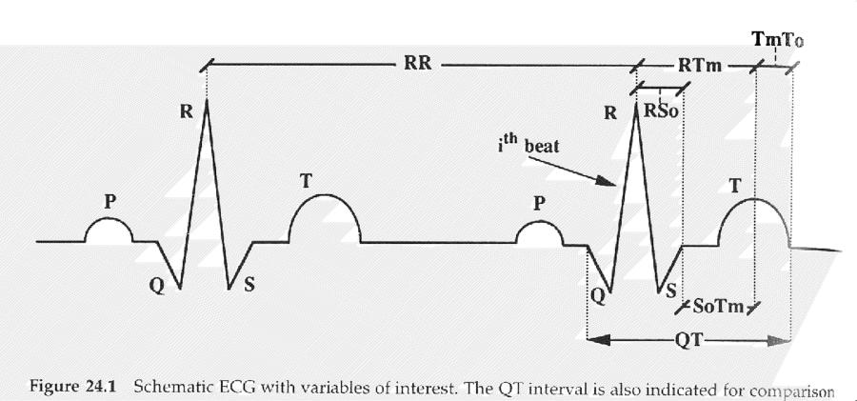
Ref: V. Cherkassky and S. Kilts (2001), Myopotential denoising of ECG signals using wavelet thresholding methods, Neural Networks, 14, 1129-1137

Observed ECG = ECG + myopotential_noise
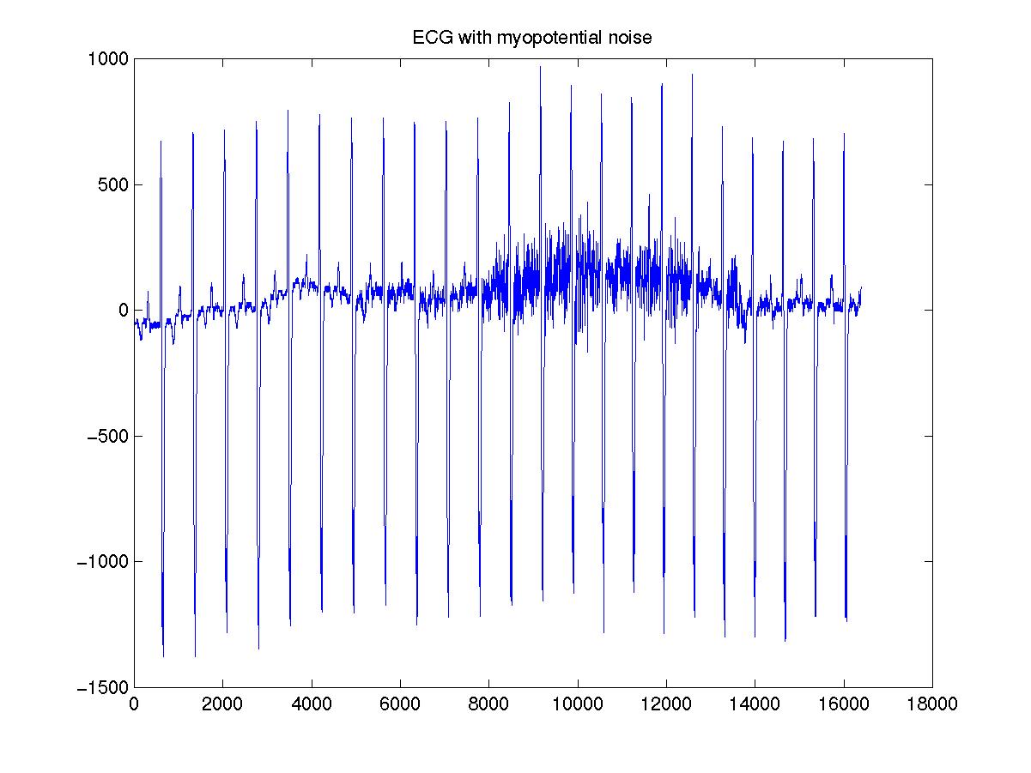

CLEAN PORTION of ECG:

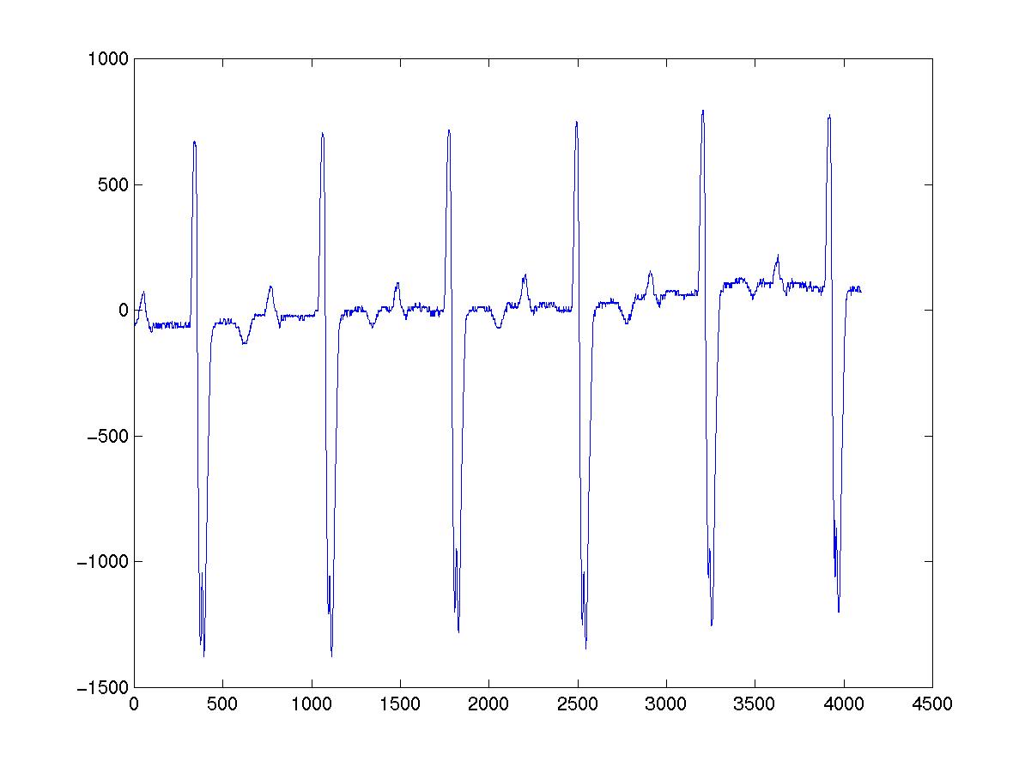
NOISY PORTION of ECG

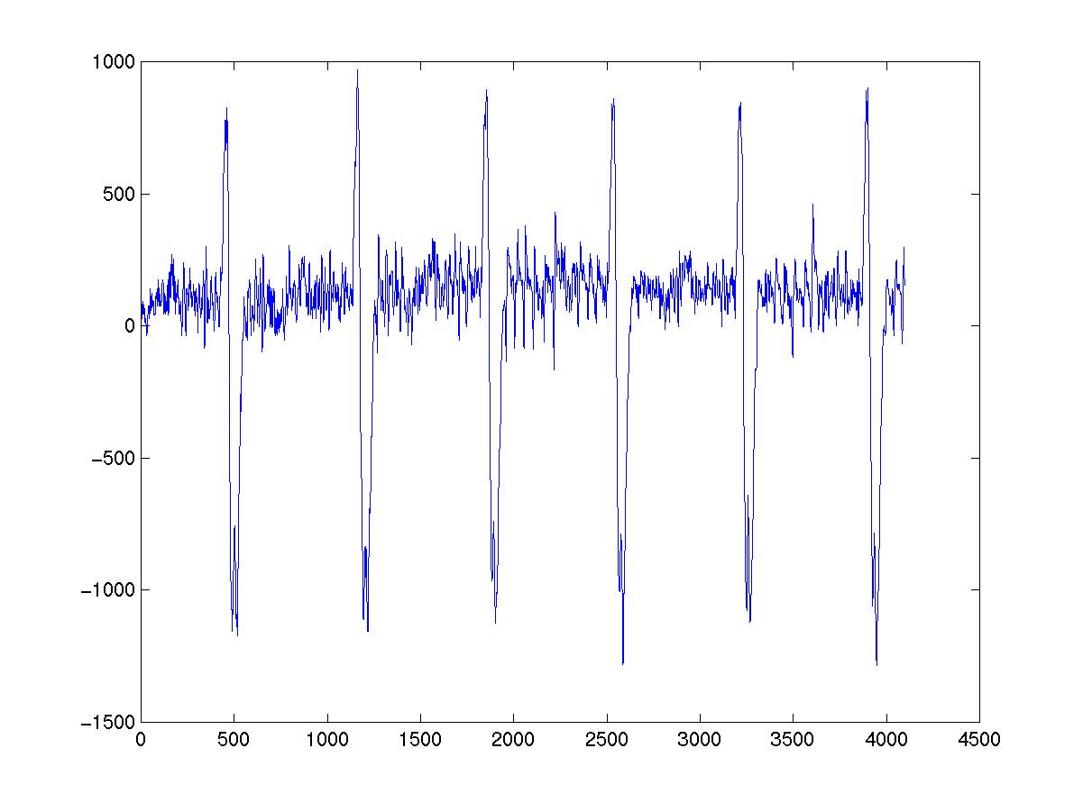
RESULT of VC-BASED WAVELET DENOISING
Sample size 1024, chosen DOF = 76, MSE = 1.78e5
Reduced noise, better identification of P, R, and T waves

vs SOFT THRESHOLDING (best wavelet method)
DOF = 325, MSE = 1.79e5

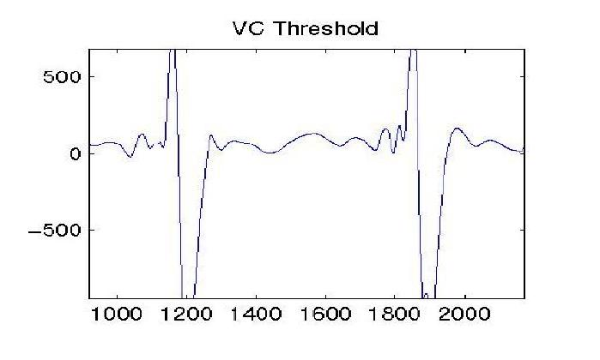
NOTE: MSE values refer to the noisy section only

- IMPROVED VC-BASED SIGNAL DENOISING

Need correct VC-dim when using VC-bounds

- VC-dimension for nonlinear estimators
- VC-dimension = DoF only hold true for linear estimator
- Wavelet thresholding = nonlinear estimator
- Estimate ‘correct’ VC-dimension as:
$$h≈\frac{1}{δ}m$$
- How to find good δ value ?

Standard VC-denoising: VC-dimension = DoF (h = m)

Improved VC-denoising: using ‘good’ δ value for estimating VC-dimension in VC-bounds

EMPIRICAL APPROACH for ESTIMATING VC-DIM.

- An IDEA: use known form of VC-bound to estimate optimal dependency δ_{opt} (m,n) for several synthetic signals.
- HYPOTHESIS: if VC-bounds are good, then using estimated dependency δ_{opt} (m,n) will provide good denoising accuracy for all other signals as well.
- IMPLEMENTATION: For a given known noisy signal
- using specific δ in VC-bound yields DoF value m*(δ);
- we can find opt. DoF value m_{opt} (since the target is known)
- then opt. δ can be found from equality m_{opt} ~ m*(δ)
- the problem is dependence on random noisy signal.

- STABLE DEPENDENCY between δ_{opt} and m_{opt}
- stable relation exists independent of noisy signal
$$δ_{\text{opt}}=ϕ_{n}(m_{\text{opt}})$$
- If m_{opt}/n is less than 0.2, the relation is linear:
$$δ_{\text{opt}}=ϕ_{n}(m_{\text{opt}})≈a_{0}(n)+a_{1}(n)\frac{m_{\text{opt}}}{n},\text{ if }\frac{m_{\text{opt}}}{n}≤0\text{.}2$$
EMPIRICAL RESULTS
- Estimation of the relation between δ_{opt} and m_{opt}.
Target Signals Used
(a) doppler | (b) heavisine
(c) spires | (d) dbsin
- Samples Size: 512 pts and 2048 pts
- SNR Range: 2-20dB (for 512pts), 2-40dB (for 2048 pts)

- Linear Approximation
(a) n = 512
(b) n = 2048

VC-dimension Estimation
VC-dimension as a function of DoF(m) for ordering:
$$\frac{|w^{0}|}{f^{0}}≤\frac{|w^{1}|}{f^{1}}≤⋯≤\frac{|w^{n−1}|}{f^{n−1}}$$
for n = 2048 samples

n=2048pts

NOTE: when m/n is small (< 5%) then h ≈ m.
PROCEDURE for ESTIMATING δ_{opt}

- For a given noisy signal, find an intersection between
- stable dependency and
- signal-dependent curve

COMPARISON RESULTS
Comparisons between IVCD, SVCD, HardTh, SoftTh.
NOTE: for HardTh, SoftTh the value of threshold is taken as:
$t=\sqrt{2\text{ln}n}σ$

Target function used:
(a) spires | (b) blocks
(c) winsin | (d) mishmash
Sample Size = 512pts, High Noise (SNR = 3dB)

(a) spires | (b) blocks
(c) winsin | (d) mishmash

- Sample Size = 512pts, Low Noise (SNR = 20dB)

(a) spires | (b) blocks
(c) winsin | (d) mishmash

- Sample Size = 2048pts, High Noise (SNR = 3dB)

(a) spires | (b) blocks
(c) winsin | (d) mishmash
- Sample Size = 2048pts, Low Noise (SNR = 20dB)

(a) spires | (b) blocks
(c) winsin | (d) mishmash

FMRI SIGNAL DENOISING
- MOTIVATION: understanding brain function
- APPROACH: functional MRI
- DATA SET: provided by CMRR at University of Minnesota
- single-trial experiments
- signals (waveforms) recorded at a certain brain location show response to external stimulus applied 32 times
- Data Set 1 ~ signals at the visual cortex in response to visual input light blinking 32 times
- Data Set 2 ~ signals at the motor cortex recorded when the subject moves his finger 32 times
FMRI denoising = obtaining a better version of noisy signal
- Denoising comparisons:
Visual Cortex Data

 | SoftTh | IVCD(0.8)
DoF | 77 | 101
MSE | 0.0355 | 0.0247
 | 0.5640 | 0.3371

Motor Cortex Data

 | SoftTh | IVCD(0.9)
DoF | 104 | 148
MSE | 0.0396 | 0.0235
 | 0.5140 | 0.3053

IMAGE DENOISING
• Same Denoising Procedure:
- Perform DWT for a given noisy image
- Order (wavelet) coefficients
- Perform thresholding (using VC-bound)
- Obtain denoised image
• Main issue: what is a good ordering (structure) ?
- Ordering 1 ('Global' Thresholding)
Coefficients are ordered by their magnitude:
$$\left|w^{0}\right|≤\left|w^{1}\right|≤⋯≤\left|w^{n−1}\right|$$
- Ordering 2 (same as for 1D signals in VC-denoising)
Coefficients are ordered by magnitude penalized by scale S:
$$\frac{|w^{0}|}{S^{0}}≤\frac{|w^{1}|}{S^{1}}≤⋯≤\frac{|w^{n−1}|}{S^{n−1}}$$
- Ordering 3 ('level-dependent' thresholding):
$\frac{|w^{0}|}{\sqrt{S^{0}}}≤\frac{|w^{1}|}{\sqrt{S^{1}}}≤⋯≤\frac{|w^{n−1}|}{\sqrt{S^{n−1}}}$
- Ordering 4 (tree-based): see references
J. M. Shapiro, Embedded Image Coding using Zerotrees of Wavelet coefficients, IEEE Trans. Signal Processing, vol. 41, pp. 3445-3462, Dec. 1993
Zhong & Cherkassky, Image denoising using wavelet thresholding and model selection, Proc. ICIP, Vancouver BC, 2000

Example of Artificial Image
Image Size: 256×256, SNR(Noisy Image) = 3dB
Original Image | Noisy Image
Denoised by HardTh  (DoF = 241, MSE = 0.01858) | Denoised by VC method  (DoF = 104, MSE = 0.02058)

VC-based Model Selection

4. SUMMARY and DISCUSSION

• Application of VC-theory to signal denoising

• Using VC-bounds for nonlinear estimators

• Using VC-bounds for sparse feature selection

• Extensions and future work:

- image denoising;
- other orthogonal estimators;
- SVM

• Importance of VC methodology: structure, VC-dimension

• QUESTIONS

ACKNOWLEDGENT:
This work was supported in part by NSF grant ECS-0099906.
Many thanks to Jun Tang from U of M for assistance in preparation of tutorial slides.

